Journal: Ecological Applications
Manuscript type: Article
Title: Hydrologically connected constructed wetlands meaningfully contribute to nutrient retention in Great Lakes watersheds

Authors:
Kenneth J. Anderson^{1*}, Lauren Brown², Mary Ellen Klukow¹, Raissa Marques Mendonca¹, Olivia Schloegel¹, Jakob Boehler³, David Dean⁴, Connor Gluck¹, Hana Esber¹, Ethan Glassman², Haley Hoehn⁵, Lindsay Horan⁶, Genna Hunt², Ewan Isherwood², Morgan Jutte⁵, Corbin Kohart², Austin Nainiger⁴, Alexandra Ochs¹, Ishfaq Rahman⁴, Madison Rice³, Leticia Sandoval⁴, Joseph S. Smith⁶, Zach Swan⁴, Christie Bahlai¹, Richard Becker⁴, Thomas Bridgeman⁴, David M. Costello¹, Stephen J. Jacquemin⁵, Ganming Liu², Nathan Manning², Kevin E. McCluney², Silvia Newell⁷, Helen Michaels², W. Robert Midden², Ryan Winston⁶, Lauren Kinsman-Costello¹
* = corresponding author; kande120@kent.edu
Affiliations: 1. Kent State University, 2. Bowling Green State University, 3. Heidelberg University, 4. University of Toledo, 5. Wright State University, 6. Ohio State University, 7. Michigan Sea Grant
Ask Chris Winslow, Kristen Fussel, Eric Saas, and Janice Kerns if they want to be authors

ADD YOUR NAME BELOW TO STATE YOUR APPROVAL AFTER READING:
Kenny Anderson, Morgan Jutte, Stephen Jacquemin, Ganming Liu, Haley Hoehn, Austin Nainiger, Mary Ellen Klukow, Ryan Winston, Ishfaq Rahman, Hana Esber, Leticia Sandoval, Bob Midden, Dave Costello, Kevin McCluney, Alexandra Ochs

Open Research Statement:

Key words: Wetland restoration; Monitoring; Phosphorus; Nitrogen; Nutrient retention, Connectivity; HABs

Abstract
Eutrophication associated with non-point source nutrient loads is a global problem, and wetland construction is becoming increasingly common as a means of treating non-point source runoff. However, the effectiveness of wetlands at capturing nutrient runoff is highly variable and our understanding of the drivers of nutrient retention in constructed wetlands is limited. To better understand how constructed wetlands retain nutrients we monitored 24 wetlands in Ohio, constructed through the H2Ohio initiative, and created nutrient budgets for each wetland through a mass loading approach. Our data show that almost all constructed wetlands retained nutrients and net annual retention was far higher than intermittent nutrient release. We found that inflowing volume set the maximum potential for nutrient retention as a strong driver of both nutrient retention and release. The concentration of nutrients in inflow water was not a strong predictor of nutrient retention when comparing across all wetlands studied, but when analyzing data from individual wetlands over time, inflowing concentration often played an important role. By scaling up our data we showed that constructed wetlands could meaningfully contribute to regional water quality goals, but that contribution is far more effective if nutrient retention is optimized by connecting wetlands to sources of both water and nutrients. {Citation}

1. Introduction:
Non-point source nutrient discharges, which originate across broad landscapes rather than from discrete discharge points, are a leading cause of aquatic ecosystem impairment around the world (Heisler et al. 2008, Smith and Schindler 2009, Wurtsbaugh et al. 2019). Excess nutrients drive eutrophication in aquatic habitats and can result in a variety of water quality issues including harmful algal blooms (HABs; Anderson et al. 2002, Wurtsbaugh et al. 2019). The creation or restoration of wetlands is a common approach to mitigate non-point source nutrients because wetlands treat runoff from areas across the watershed and create a focal point where non-point source pollution can be concentrated and processed (Carpenter et al. 1998, Vymazal 2007, Weisner et al. 2016a).
Wetlands are nutrient-cycling hotspots that capture and process nutrients (McClain et al. 2003, Cheng and Basu 2017). Even small and seemingly disconnected wetlands can play major roles in landscape-scale rates of nutrient cycling when they are in high abundance (Marton et al. 2015, Cheng et al. 2023). The Grand Lake St. Marys watershed (located in northwest Ohio) has become emblematic of the effects of elevated nutrients in runoff, as well as wetland-centric conservation practices; over 1,000 acres of wetlands have been constructed in the watershed over the past decade (Jacquemin et al. 2018). These wetlands treat more phosphorus (P) and nitrogen (N) than what their spatial footprints might suggest. For example, Coldwater Creek Restored Wetland has been in operation for about 10 years, and while its surface area is 0.2% of the sub-watershed, it has been shown to process nearly 5% of the total annual nutrient load (Jacquemin et al. 2025).

Constructed wetlands have demonstrated potential to successfully treat watershed nutrient loading; however, the designs of constructed wetlands with highest nutrient processing capacity are rooted in a deep understanding
of the underlying wetland nutrient retention mechanisms (Kadlec 2016, Ury et al. 2023). Wetlands initially capture nutrients by retaining water and reducing flow velocity, which allows time for sedimentation of particles and associated nutrients (Mitsch et al. 2014, Aziz and Van Cappellen 2021), adsorption of phosphate and ammonium to binding sites on sediment, and nitrogen removal (Collins et al. 2016). Dissolved nitrogen can be converted to N₂ gas and removed from the system via denitrification (the stepwise reduction of nitrate to N₂; Seitzinger et al. 2006) or anammox (anaerobic ammonia oxidation by nitrite; (Koop-Jakobsen and Giblin 2009). Longer-term storage occurs through sediment trapping and nutrient uptake by vegetation, which transforms inorganic N and P into less bioavailable organic forms that may be stored by perrenial plants across years(Silvan et al. 2004, Lucas and Greenway 2008). However, despite the clear potential of wetland restoration for nutrient retention, there are examples of restored wetlands that release nutrients rather than retain them (Ardón et al. 2010, Kinsman-Costello et al. 2014). This makes the study of what processes determine whether a wetland is a net ‘source’ vs. ‘sink’ particularly significant(Ardón et al. 2010, Steinman and Ogdahl 2011). Initial nutrient load to the wetland, the hydrologic residence time, invasive plant encroachment, and state factors (wetland age, temperature, etc.) all contribute to the wetland’s ability to reduce nutrient loads (Fisher and Acreman 2004, Sharp et al. 2021, Yousaf et al. 2021), but an understanding of how to manipulate important drivers to improve restoration of nutrient retention is still limited.
A variety of indices are often used as proxies to evaluate wetland restoration success, including vegetation diversity and cover, and hydrologic regime, but many of these may not accurately assess a wetland’s ability to retain nutrients (Fennessy et al. 2007). The drivers of nutrient retention in wetlands are not yet clearly understood, with highly variable rates of nutrient retention observed across a variety of studied wetlands (Land et al. 2016, Anderson et al. 2024). However, through nutrient budgeting methods, we know that wetlands that receive high nutrient loading consistently retain more phosphorus (Land et al. 2016, Ury et al. 2023), at least until P-binding sites are saturated (Jacquemin et al. 2025). Thus, a deeper understanding of how nutrient loading affects nutrient retention by constructed wetlands through connectivity to both runoff and nutrients is warranted to better support future wetland restoration. This will enable practitioners to optimize wetlands for nutrient retention and accurately assess water quality tradeoffs when creating wetlands for other primary goals such as wildlife habitat, flood abatement, or biodiversity.
To investigate the drivers of nutrient retention in wetlands, we created empirically-based nutrient budgets for 24 constructed wetlands monitored across Ohio (Lake Erie and Aquatic Research Network (LEARN): Wetlands and Water Quality Group (H2Ohio Wetland Monitoring Program) 2026). We calculated nutrient budgets on both monthly and annual scales using a mass balance approach, collecting nutrient concentration and water volume data at the inlet and outlet of each wetland and calculating retention as the difference in nutrient load between the inlet and the outlet of the wetland. We aimed to address three main questions: 1. How much does connectivity of constructed wetlands to both runoff and nutrients contribute to their ability to retain nutrients? 2. What drives potential for nutrient release in constructed wetlands? 3. Can constructed wetlands feasibly contribute to landscape-scale nutrient retention goals? To evaluate the effects of connectivity on constructed wetland nutrient retention, we built linear mixed effects models with monthly measures of inflow volume and nutrient concentrations as predictors of nutrient retention across all 24 wetlands. To investigate the drivers of nutrient release potential, we built logistic regressions to assess the effects of nutrient load timing, inflow volume, and nutrient concentration on nutrient retention. To evaluate whether wetlands can feasibly contribute to landscape-scale nutrient load reduction goals, we built three hypothetical scenarios based on the nutrient retention estimates of the 24 monitored wetlands to extrapolate the total land area that would need to be converted to wetlands to meet the Lake Erie nutrient loading goal based on International Joint Council targets (Ohio Environmental Protection Agency (EPA) 2023), explicitly considering 1) typical wetlands, 2) hydrologically connected wetlands, and 3) best-performing wetlands.

2. Methods:
2.1 Site Descriptions
We analyzed data from 24 wetlands built by conservation organizations with support from the Ohio Department of Natural Resources as part of the H2Ohio water quality initiative (“H2Ohio | Ohio.gov”; Figure 1), which has to date created or restored 498 wetlands across Ohio, especially focusing on the Maumee River Drainage Basin of Northwest Ohio. The goal of the H2Ohio program is to improve water quality throughout Ohio, with special focus on mitigating harmful algal blooms in Lake Erie through phosphorus load reduction (International Joint Commission 2014). Harmful algal blooms in Lake Erie are primarily driven by agricultural runoff (Michalak et al. 2013); the state of Ohio and the Maumee River Drainage basin are over 50% and 80% agricultural land, respectively (Ohio Environmental Protection Agency (EPA) 2023). Wetland restoration in Northwestern Ohio is especially relevant because the landscape was radically altered starting in the early 1900s when the Great Black Swamp, a wetland that covered 1 million acres of Northwestern Ohio, was drained for agricultural production (Mitsch 2017). Wetland restoration in the drainage basin had been sporadic until 2014 when the Toledo drinking water crisis spurred interest in restoration (Michalak et al. 2013, Bingham et al. 2015), which led to the establishment of the H2Ohio Initiative which has been a major investment in wetland restoration across the state.
This analysis focused on data from the H2Ohio Wetland Monitoring program across 24 wetlands with sufficient data to calculate a nutrient mass balance budget (Kinsman-Costello et al. 2024). Twenty of the 24 wetlands had drainage areas with >60% agricultural land use, three of the four remaining had drainage areas with >70% urban land use, and one had a drainage area evenly split between forest and agriculture. Source water varied between wetlands; 17 of the 24 wetlands received inflow from rivers, three had direct coastal connections with lakes, and six had direct agricultural tile drain inflows.
2.2 Nutrient Budgets
2.2.1 Water Volume
Wetland nutrient retention was calculated using a mass balance budgeting approach, where inflowing and outflowing volumes of water were multiplied by inflowing and outflowing nutrient concentrations for each wetland.

Nutrient load in=inflowing concentration x inflowing volume
Nutrient load out=outflowing concentration x outflowing volume
Nutrient retention=Nutrient load in-Nutrient load out

We calculated the nutrient retention for 24 wetlands from 2021 to 2025, for a total of 44 annual retention scenarios. Monitoring efforts at each wetland accounted for individuality of the wetland, logistical constraints, and labor availability. Specific details for each wetland are described in the supplemental material (SI: Nutrient budget methods). Cumulative monthly and annual water inflow and/or outflow volume was estimated at all 24 wetlands through either direct measurement of pumping rates (n = 3), stage-storage models (n = 13), estimation of flow based on the NRCS curve number method (n = 1; USDA-NRCS 2004), watershed weighting using discharge from USGS gauges (n = 1), or water depth and weir equations (n = 7). For wetlands where either the inflow or outflow volume was not directly measured (n = 16), evapotranspiration was used to estimate the unmeasured value.
Reference evapotranspiration (ET₀) values across wetlands were calculated from meteorological data using the Penman-Monteith FAO-56 method (Allen et al., 1998). Daily meteorological inputs, including minimum and maximum air temperature, minimum and maximum relative humidity, and wind speed at 2 meters height, were obtained from the nearest Ohio station of the Automated Surface Observing System (ASOS) network via the Iowa Environmental Mesonet (IEM). Where wind speed was only available at 10 meters, it was adjusted to the 2-meter reference height using the logarithmic wind profile equation (Allen et al. 1998). Atmospheric pressure was either obtained directly from ASOS station records or estimated from the elevation above sea level of the wetland using the barometric formula:
$$P=P_{0}⋅{(\frac{T_{0}-L⋅h}{T_{0}})}^{\frac{g}{R⋅L}}$$
where $P$ is the atmospheric pressure (kPa) at $h$, $P_{0}$ and $T_{0}$ are respectively the reference pressure and temperature at sea level, $L$ is the temperature lapse rate in the troposphere, $h$ is elevation above sea level (m), $g$ is the gravitational acceleration, and $R$ is the universal gas constant for air. Daily solar radiation (MJ/m²/day) was sourced from the National Aeronautics and Space Administration (NASA) Langley Research Center's Prediction of Worldwide Energy Resources (POWER) database using the wetland coordinates and the nasapower R package (Sparks 2018).
The Penman-Monteith FAO-56 equation combines a radiation term (r_{s}) and an aerodynamic term (r_{a}) to estimate the evaporative demand of the atmosphere over a hypothetical reference crop (Allen et al., 1998). Key intermediate variables (e.g., slope of the saturation vapor pressure curve, the psychrometric constant, mean saturation and actual vapor pressure) were calculated from the daily meteorological inputs and wetland-specific parameters (latitude, elevation). Soil heat flux density ($G$) was assumed to be negligible for daily time-step calculations, consistent with FAO-56 guidance.
2.2.2 Nutrient Concentrations
Nutrient concentrations at the inlet and outlet of each wetland were sampled at least monthly for all wetlands except for five that only received or released water via water control structures or during storm events; nutrient concentrations for those five wetlands were only collected during periods of flow into or out of the wetland. Of the other 19 wetlands, 12 were sampled monthly and seven were sampled every other week (i.e., primarily during baseflow or inter-event conditions). Eighteen wetlands received flow during storm events and in addition to monthly sampling had at least 1 storm event sampled (average of 4 storm samples per wetland), while six wetlands only had inflows through pumps or water control structures. Nutrient concentrations were assumed to stay constant in between sampling points except during storm events, where they were changed based on storm concentration data available for each wetlands (SI: Nutrient Budget Methods).
2.2.3 Estimating Wetland Runoff Prevention

The processing of new nutrients is not the only way that wetlands contribute to nutrient reductions across a watershed. To scale up our measured nutrient loading we need to account for both the active treatment of nutrients by wetlands as well as how wetland creation alters nutrient loads by preventing nutrient loss from former agricultural areas. To account for the effects of replacing agricultural land with wetlands, including reduced fertilizer application and runoff, we assume wetlands are no longer fertilized and store water that would previously have runoff the landscape due to the disruption of tile drains. Pre-construction runoff data do not exist for the agricultural fields that were converted to wetlands so we used data from the USDA-NRCS Edge of Field network for Northwest Ohio wetlands and applied the mean annual runoff estimate to the number of acres within each H2Ohio project that taken out of agricultural production and converted to either wetland or restored upland habitat to estimate the mean runoff prevention (Hanrahan et al. 2019).
2.2.4 Upscaling Phosphorus Retention with Maumee TMDL Goals
To compare phosphorus retention rates to regional goals, we used the Maumee Watershed Total Maximum Daily Load (TMDL) guidelines (Ohio Environmental Protection Agency (EPA) 2023). Across the 2.5-million-acre portion of Maumee watershed in Ohio, the TMDL aims to reduce phosphorus loading in March–July by a total of 1 million lbs. (442 metric tons), with 20% of that reduction expected to come from systems that can function as sinks to non-point source P inputs, such as wetlands. To account for a range of wetland construction practices, we compared three scenarios: “typical” H2Ohio wetlands (i.e., representative of commonly occurring wetlands across the portfolio, generally with sporadic connectivity to source water; 50th percentile nutrient retention), hydrologically connected wetlands (75th percentile nutrient retention), and the best-performing wetlands (i.e., maximum retention recorded among 24 monitored wetlands). We first calculated total P retention during the HAB season (March–July) by adding the mean P runoff prevention based on acreage converted from agriculture to the 50th, 75th, or maximum P retention in lbs./acre from monitored H2Ohio wetlands (Hanrahan et al. 2019). We then scaled the P retention in lbs/acre for each scenario by the median percent P retention (i.e., of total annual; 65%) during the HAB season across all monitored H2Ohio wetlands. To calculate the total wetland acreage needed to meet the TMDL goal, we divided the goal of 200,000 lbs. P by the P retention across the three scenarios.
To compare nitrogen retention rates to regional goals, we used the proposed nitrogen goals from Paerl et al. (2024). They propose a 40% reduction of N compared to the 2008 baseline for the Maumee Watershed (~18 million lbs). To create a N goal for non-point source sinks, we used 20% of the total to match the same percentage as the TMDL used for P (92 metric tons / 442 metric tons); for a total reduction goal of 3.7 million lbs N. To calculate the total wetland acreage needed to meet the proposed 40% reduction, we used the same scenarios as those described above for P.

2.3 Statistical Analysis
To investigate relationships between nutrient retention, water volume, and nutrient concentration, we constructed linear mixed effects models and logistic regressions in R (R Core Team 2024). We performed a leave-one-out analysis by sequentially running linear models while removing one wetland for each model. Then, the RMSE was calculated for the model with the wetland removed and the model predicting the removed wetland. RMSE values were calculated using version 0.1.4 of the Metrics package (Hamner et al. 2018) in R.
3. Results:
3.1. Nutrient Retention
We observed net annual nutrient filtration in most wetlands, net annual TP release in two wetlands, and net annual TN release in three wetlands across all years monitored (including the two that released TP; Table S1). TP retention ranged from –11 lbs./year to 1732 lbs./year, with a mean (± standard deviation) of 113 lbs./year (±280), and a median of 25 lbs./year. TN retention ranged from -549 lbs./year to 7345 lbs./year, with a mean (± standard deviation) of 1416 lbs./year (±1812) and a median of 711 lbs./year (Table 1). Of the 528 wetland-months (unique combinations of wetland and month), 60% (313 wetland-months) indicated net TP retention, 13% (72 wetland-months) indicated net TP release, and 27% (143 wetland-months) indicated no net release or retention of P. Within that same dataset, 64% (336 wetland-months) indicated net retention of N, 9% (49 wetland-months) indicated net release of N, and 27% (143 wetland-months) indicated no net release or filtration of N. For most wetlands, retention outweighed release in terms of both total mass and number of months. Retention of both TP and TN, across all wetlands, occurred primarily during spring (March through May) and summer (June through August), with 38% of TP and 45% of TN filtered in the spring and 38% of TP and 36% of TN filtered in the summer (Figure 2). Dissolved nutrients were similarly retained primarily during spring with 34% of DRP processed in the spring and 39% in the summer, 44% of nitrite+nitrate processed in the spring and 38% in the summer, and 18% of total ammonium nitrogen (NH₄) processed in the spring and 58% in the summer.
3.2 Drivers of Nutrient Retention Across Wetlands
Monthly nutrient retention and release across wetlands were significantly related to inflow volume. Across months and wetlands, the log-scale total monthly mass of both TP and TN removed and/or released was strongly related to the log-scale monthly inflow volume (TP: R² = 0.83 for retained, R² = 0.59 for released; TN: R² = 0.8 for retained, R² = 0.58 for released; Figure 3). While there is a significant relationship between retention and concentration for both TP and TN, the variability explained therein is limited compared to volume (TP: R² = 0.01, TN: R² = 0.15; Figure 3). We found similar relationships between inflow volume and retention of dissolved nutrients DRP (R² = 0.76), NO_{x} (R² = 0.70), and total ammonium nitrogen (NH₄, R² = 0.76), as well as between inflow volume and release of dissolved nutrients for DRP (R² = 0.52), TN (R² = 0.48), NO_{x} (R² = 0.45), and ammonium nitrogen (R² = 0.28). Similarly, weak relationships existed between concentration and filtration for DRP (R² = 0.03), NO_{x} (R² = 0.03), and NH₄ (R² = 0.00).
Nutrient retention was calculated in part using both inflow volume and inflowing nutrient concentrations, which we then use as predictors of nutrient retention. These values are valid predictors because we are investigating the effect of the wetland, which cannot change the influent volume or concentration, only the concentration and volume leaving (which we do not use as predictor variables). Additionally, the influent composition and volume is a critical factor for nutrient retention in wetlands(Sharp et al. 2021, Ury et al. 2023). To ensure that the relationship between inflow volume and nutrient retention was both not reliant on an individual wetland to drive the pattern and also robust to independent data, we remade the model sequentially removing wetlands from the database to perform a leave-one-out analysis. The model predictions were robust to the exclusion of individual wetlands with mean RMSE values of 3.2lbs for TP, 3.5lbs for TN, 4.2lbs for DRP, 7.5lbs for NO_{x}, and 4.7lbs for NH₄. We then applied each new model to predict nutrient retention at the removed wetland and found that mean RMSE when predicting nutrient retention in wetlands not included in the model was similar to predictions when data was included (mean RMSE: 3.1lbs for TP, 3.3lbs for TN, 4.2lbs for DRP, 9lbs for NO_{X}, 4.6lbs for NH₄). Wetlands did, however, vary in their ability to be predicted when excluded from the model (Figure S1).
3.3 Drivers of Nutrient Retention Within Wetlands
While we found that inflow volume had a stronger correlation with nutrient retention than concentration, individual wetlands’ nutrient concentrations often were similar or occasionally a more important predictor of nutrient retention than inflow volume. Linear models predicting nutrient retention by inflow volume and concentration for each individual wetland and predictor t-values indicated that concentration is sometimes a more significant predictor and often a similarly important predictor to inflow volume (Figure 4). Based on model t-values, TP concentration was a more significant predictor than inflow volume at two wetlands and within the same order of magnitude at eight more wetlands. TN concentration was a more significant predictor than inflow volume at four wetlands and within the same magnitude at seven more wetlands. DRP concentration was a more significant predictor than inflow volume at three wetlands and within the same magnitude at seven more wetlands. NO_{x} concentration was a more significant predictor than inflow volume at six wetlands and within the same magnitude at four more wetlands. NH₄ concentration was a more significant predictor than inflowing volume at three wetlands and within the same magnitude at eight more wetlands (Figure 4).
3.4 Drivers of Nutrient Release
To understand patterns of nutrient release, we performed a logistic regression with month, inflowing concentration, and inflow volume as predictors of whether nutrients were retained or released. Inflow nutrient concentration was the only significant predictor of nutrient release for both TP (Logistic Regression; z = -3.74, p < 0.01) and TN (Logistic Regression; z = -4.13, p < 0.01), with higher probability of release at lower nutrient concentrations (Figure 5). Neither month (TP: z = -1.0, p = 0.3, TN: z = 0.37, p = 0.7) nor inflow volume (TP: z = -0.16, p = 0.9, TN: z = -0.62, p = 0.5) were significant predictors of nutrient release. Inflow TP concentration during months with net release of TP (mean 0.16±0.15 mg/L) were significantly lower than during months with net retention of TP (mean 0.39±0.40 mg/L; Welch Two-Sample t-test, t = 7.4, p < 0.01). Inflow TN concentration during months with net releases of TN (mean 2.11±1.66 mg/L) were significantly lower than during months with net retention of TN (mean 5.08±4.78 mg/L; Welch Two-Sample t-test, t = 7.9, p < 0.01).
3.5 Nutrient Retention Over Time
We have currently collected 3 or more years of data at 5 of the 24 total wetlands. There were no consistent trends across years within any of the 5 wetlands. Wetland nutrient retention decreased for most monitored wetlands in 2024 but then increased in 2025. The efficiency of nutrient retention varied from year to year, but there was not a consistent or significant directional trend across wetlands (Figure 6).
3.6 How Many Wetlands Are Needed to Meet Nutrient Retention Goals?
We constructed three scenarios to address how many wetlands would need to be constructed to meet the Maumee Watershed TMDL goal of 200,000 lbs P retained using wetlands. The total P retentions calculated for the HAB season accounting for both wetland retention and runoff prevention were 1.95 lbs/acre for typical wetlands (50th percentile), 5.2 lbs/acre for connected wetlands (75th percentile), and 114 lbs/acre for the best performing wetlands (100th percentile; Table 2). This means that 120,000 acres of typical wetlands, 40,000 acres of connected wetlands, or 2,000 acres of the best performing wetlands would be needed to meet Maumee Watershed TMDL goals.
Similarly, we calculated that the total N retention during the HAB season, accounting for both wetland retention and runoff prevention, was 41.8 lbs/acre for typical wetlands, 140.5 lbs/acre for connected wetlands, and 629.1 lbs/acre for the best performing wetlands (Table 2). This means that 88,000 acres of typical wetlands, 26,000 acres of connected wetlands, or 6,000 acres of the best performing wetlands would be needed to meet Maumee Watershed TMDL goals.
In total the conversion of 1% of current agricultural land (2.6 million acres) in the Maumee River watershed to hydrologically connected wetlands would meet TMDL goals for wetland contribution to P retention during the HAB season and would nearly double proposed reductions for N.
4. Discussion:
4.1. Hydrologic connectivity and nutrient retention
We found that all H2Ohio wetlands retain nutrients on an annual scale, but low-magnitude, transient releases are common across these wetlands. Meta-analyses have shown that wetlands typically retain nutrients (Land et al. 2016, Ury et al. 2023), but ours is one of the largest studies on nutrient retention with consistent monitoring methods across all constructed wetlands. We found a strong relationship between inflow volume and nutrient retention, as well as a strong relationship between inflow volume and nutrient release across H2Ohio constructed wetlands. This suggests that inflow volume sets the scale for nutrient retention: higher volumes of water lead to higher retention or release. While we did not find that concentration of either P or N were significant predictors of nutrient retention across these wetlands, we did find that it was often important, and occasionally more important than volume, as a predictor of nutrient retention within individual wetlands over time. Higher volume of water likely plays a role both by determining the total mass of nutrients delivered to the wetland and by controlling the residence time within the wetland(Sharp et al. 2021, Ury et al. 2023).
Although the amount of water that can be treated across wetlands does vary, the volume and residence time of water within an individual wetland does not change. When a wetland receives too much water and its residence time is shortened, nutrient retention efficiency decreases because the water is not slowed enough to allow settling, and there is less time for sorption of phosphate, plant uptake, and microbial denitrification (Jiang and Mitsch 2020, Hambäck et al. 2023). Wetlands that don’t get enough water and have more time than for phosphorus bind in sediments and denitrification to draw down nitrate concentrations can also get stagnant and will release phosphorus and ammonia if the water column goes anoxic (Muller et al. 2016). However, the scale of change in volume across wetlands is important in this context, because differences in volume, and thereby load, can outweigh reductions in efficiency. For example, a wetland that retains 99% of 10 lbs of phosphorus (9.9 lbs) is contributing less to watershed-scale nutrient retention than a wetland that retains only 10% of 100 lbs of phosphorus (10 lbs).
Understanding how major storm events, when residence times are short and large volumes of water enter wetlands, affect nutrient retention dynamics is critical for accurately calculating nutrient budgets (Anderson et al. 2024). Storm events are when most of the water and nutrients move across the landscape in agricultural drainages and deliver high concentrations of nutrients for wetlands to retain (D’Amario et al. 2021, Johnson et al. 2024). While wetlands receiving continuous flow have often been found to be more effective than flood pulse wetlands (Díaz et al. 2012), many constructed wetlands are designed to only receive water during storm events, making their ability to capture high volumes of water in a short period of time even more important. Our analysis supports the importance of capturing data during storm events, but our interpretation of our storm data is limited by the infrequency of nutrient sample collection during storm events and a lack of understanding of the relationship between concentration and discharge at both the inlet and outlet of wetlands during storms. Our understanding of nutrient retention in constructed wetlands is also limited by the lack of long-term data (Anderson et al. 2024). Three of the four years of H2Ohio monitoring have taken place during droughts, limiting our understanding of how these wetlands function during wetter conditions, which are projected to become more frequent throughout the 21st century (Prein and Mearns 2021). Additionally, three to four years of data cannot accurately predict long-term trends, especially with newly constructed wetlands that are rapidly developing (Craft 1996) and building up stores of P which might subsequently be released (Sharpley et al. 2013).
4.2 Drivers of nutrient release
Nutrients in wetlands are stored in water, sediment, or vegetation; release into the water column from sediments commonly occurs due to changing microbial or redox dynamics and/or the decomposition of organic matter(McLatchey and Reddy 1998, McCarthy et al. 2007, Steinman et al. 2012). We found no monthly or seasonal patterns that explained why wetlands released nutrients when they did, but we did find that nutrient release was more likely during low-nutrient-concentration inflows. This supports previous analyses suggesting that diffusion gradients between sediments and surface water may play an important role in determining when wetlands release nutrients (Steinman et al. 2012, Matisoff et al. 2016, Back et al. 2025). It is also well documented that drying and rewetting of sediment can lead to nutrient release (Aldous et al. 2005, Kinsman-Costello et al. 2014), which could contribute to the pattern of release during low concentration if rewetting events are associated with low concentration inflows. Longer residence time during dry periods likely also contributes, but residence time was not directly calculated for all wetlands in this study. However, multiple studies have shown that major storm events are not necessarily associated with nutrient release from wetlands, further supporting low incoming concentration as a potential cause of releases (Jordan et al. 2003, Tanner and Sukias 2011, Dunne et al. 2015).
4.3 Landscape scale retention
Our analysis to contextualize regional phosphorus and nitrogen reduction goals via three wetland scenarios (i.e., typical wetlands, connected wetlands, and best performing wetlands) highlights the importance of further study of the features that can optimize nutrient retention in both new and existing wetlands. The H2Ohio program has built 20,000 acres of wetlands and associated habitat across the state of Ohio (Ohio Department of Natural Resources 2026). Depending on optimization of wetlands’ ability to retain nutrients, 20,000 acres could represent either half of the 40,000 acres of connected wetlands needed to meet TMDL phosphorus goals or only a fifth of the 120,000 acres of typical wetlands needed; however, it is important to note that not all 20,000 acres of constructed wetlands are within the Maumee watershed. Both typical and hydrologically connected wetlands are more effective at meeting nitrogen goals than phosphorus goals, with 30% less acreage of typical wetlands, and 50% less acreage of connected wetlands needed to meet N water quality goals. However, we found that our wetlands have a higher max on phosphorus retention than nitrogen leading to less acreage of the best performing wetlands needed to treat phosphorus than nitrogen.
Our data supports past efforts that have shown that optimizing wetlands (either by modifying existing wetlands or constructing new wetlands) through ensuring high connectivity to source water can determine the effect of wetlands on landscape-scale nutrient removal (Weisner et al. 2016b). Wetlands can be highly effective tools for nutrient retention across agricultural landscapes, but their effectiveness depends on an understanding of the hydrologic and biogeochemical drivers of nutrient retention at individual wetlands (Cheng and Basu 2017, Jacquemin et al. 2025).
5. Conclusion
Our analysis of data collected as part of the H2Ohio Wetland Monitoring Program shows that H2Ohio-constructed wetlands retain nutrients, and net annual retention is far higher than intermittent nutrient releases. We additionally highlight how inflow volume sets the scale for nutrient retention as a strong predictor of both nutrient retention and release, but that inflow concentrations are important predictors of nutrient retention within individual wetlands. Wetlands can be an effective method of nutrient retention within the scale of current restoration efforts to meet regional water quality goals, however that ability relies on optimizing wetland nutrient retention and building wetlands that are connected to sources of both water and nutrients.

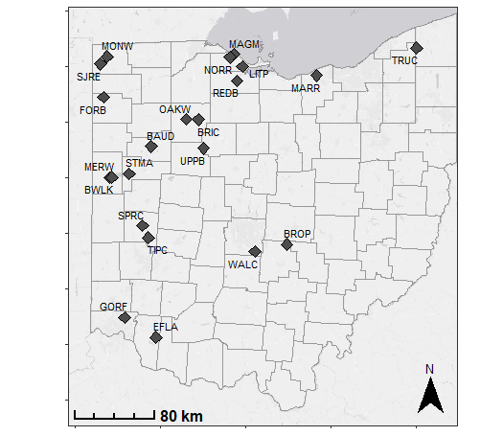
Figures:
Figure 1. Map of 24 wetland restorations where inflowing and outflowing volumes and nutrient concentrations were monitored to build nutrient budgets
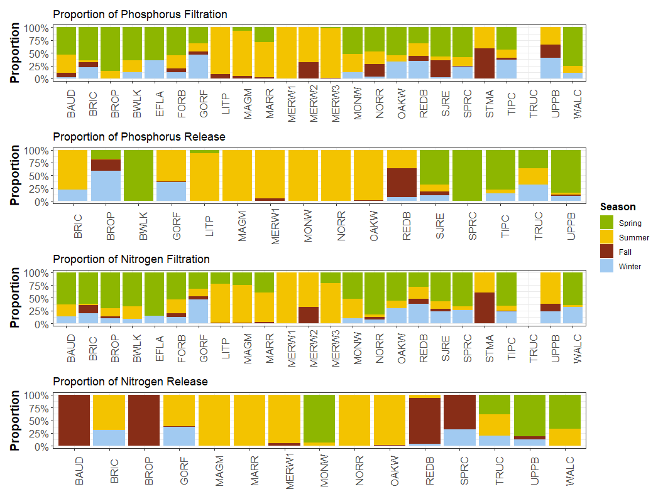
Figure 2. Proportion of total phosphorus and total nitrogen retention and release across seasons. Note this only shows the timing of filtration and release, not the magnitude. Data are grouped seasonally: fall (September 1–November 30), winter (December 1–February 28), spring (March 1–May 30), summer (June 1–August 31). For full wetland names see (Lake Erie and Aquatic Research Network (LEARN): Wetlands and Water Quality Group (H2Ohio Wetland Monitoring Program) 2026).
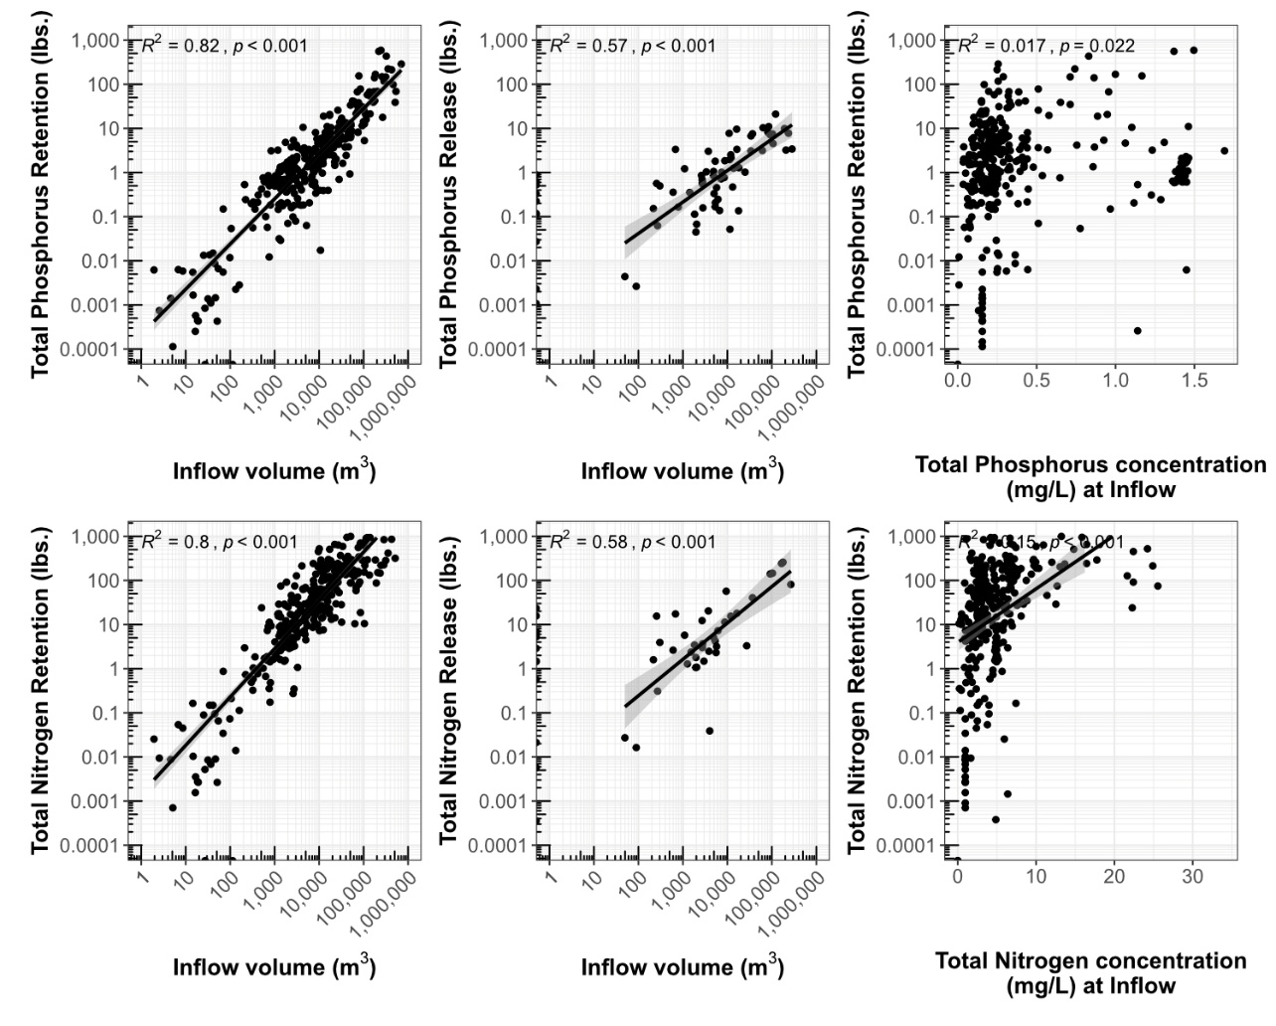
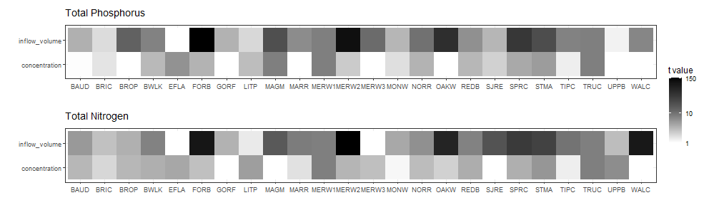
Figure 3. Linear relationships between inflow volume in meters cubed, and monthly retention and release for both total phosphorus and total nitrogen, as well as linear relationships between retention and monthly inflowing concentration for total phosphorus and total nitrogen. Data on inflow volume and nutrient retention are presented on a log scale; minor axis ticks show the log progression on each axis.
Figure 4. Heatmap of t-values for linear models predicting nutrient retention by inflowing volume and concentration for each studied wetland. Each column represents a model for an individual wetland (retention ~ inflow volume + concentration) and shade represents the t-value, with darker values indicating higher t-values.

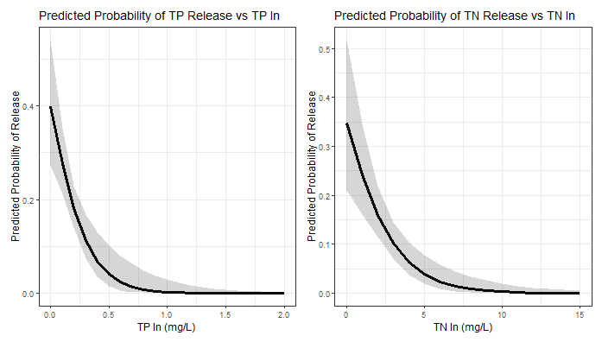
Figure 5. Probability of nutrient release based on inflow concentrations of total phosphorus and total nitrogen from logistic regressions. For both total phosphorus and total nitrogen, concentration was a significant predictor of release, whereas inflowing volume, and month were not.

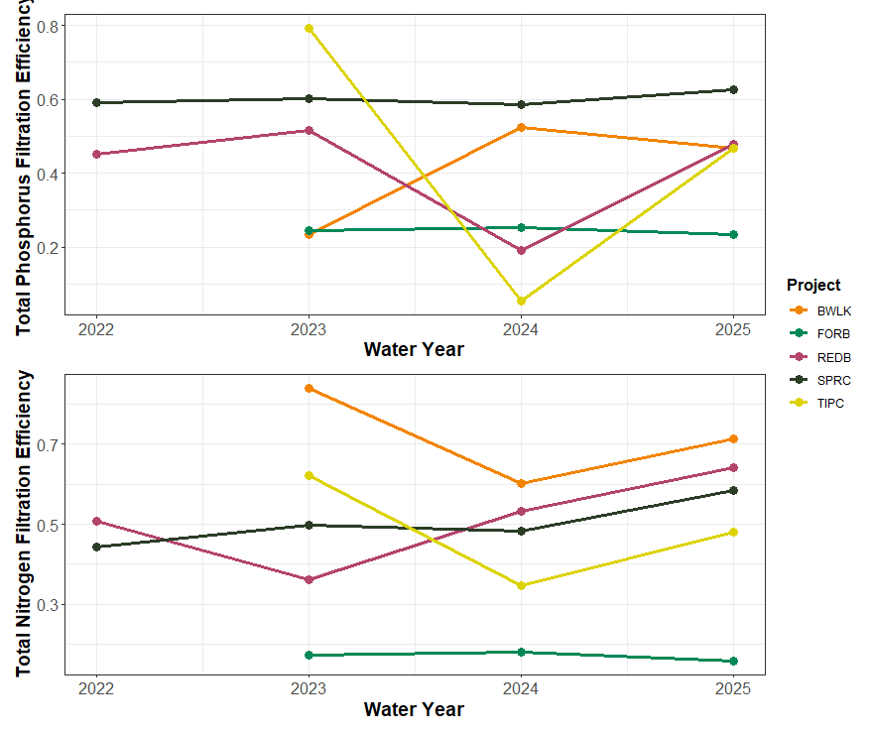
Figure 6. Change in annual phosphorus and nitrogen filtration efficiency over time across the five wetlands with three or more years of data. Nutrient filtration efficiency was calculated as the annual mass of the nutrient filtered divided by the annual total mass of that nutrient that entered the wetland.
Tables:
Table 1. Nutrient retention across all monitoring years for H2Ohio wetlands. Retention was calculated by measuring inflowing and outflowing nutrients to 24 different wetlands for between one and four years. Nutrient budgets were calculated for total phosphorus (TP), total nitrogen (TN), dissolved reactive phosphorus (DRP), nitrite+nitrate (NO_{x}), and total ammonium nitrogen (NH₄). Mean, median, and range are presented in both total lbs retained, and in lbs/acre of restored wetland.
 | Mean Nutrient Retention (lbs) | Median Nutrient Retention (lbs) | Range of Nutrient Retention (lbs) | Mean Nutrient Retention (lbs/acre) | Median Nutrient Retention (lbs/acre) | Range of Nutrient Retention (lbs/acre)
Total P | 113 | 25 | -11 to 1733 | 19 | 1 | -1 to 495
Total N | 1417 | 712 | -549 to 7345 | 127 | 25 | -32 to 968
DRP | 36 | 15 | -10 to 295 | 3 | 1 | -1 to 35
Nox | 1170 | 329 | -2 to 6904 | 91 | 18 | 0 to 756
NH4 | 42 | 4 | -75 to 421 | 3 | 0 | -21 to 36

Table 2. Wetland acres needed to meet the TMDL “enhance nonpoint source sinks” phosphorus reduction goal and proposed co-reduction goals for nitrogen for three different scenarios: Typical wetlands (using 50th percentile nutrient retention values), Connected wetlands (using 75th percentile nutrient retention values), and the best performing wetlands (using the maximum nutrient retention values). Total P retention is calculated as the P retention by wetlands plus the runoff prevention estimated based on the proportion of wetland converted from agriculture. Median P retention during the HAB season was 65% of annual retention and median N retention was 72%, so here 65% of total P retention, and 72% of total N retention are used.
Scenario | Total P retention (lbs. P / acre during HAB season) | Total N retention (lbs. N / acre during HAB season) | Wetland acres needed to meet TMDL wetland goal for TP | Wetland acres needed to meet co-reduction TN goals
1. Typical Wetlands (50th percentile) | 1.65 | 41.8 | 120,000 | 88,000
2. Connected Wetlands (75th percentile) | 4.78 | 140.5 | 40,000 | 20,000
3. Best performing Wetlands (Maximum) | 113.75 | 629.1 | 2,000 | 6,000

Supplemental Figures
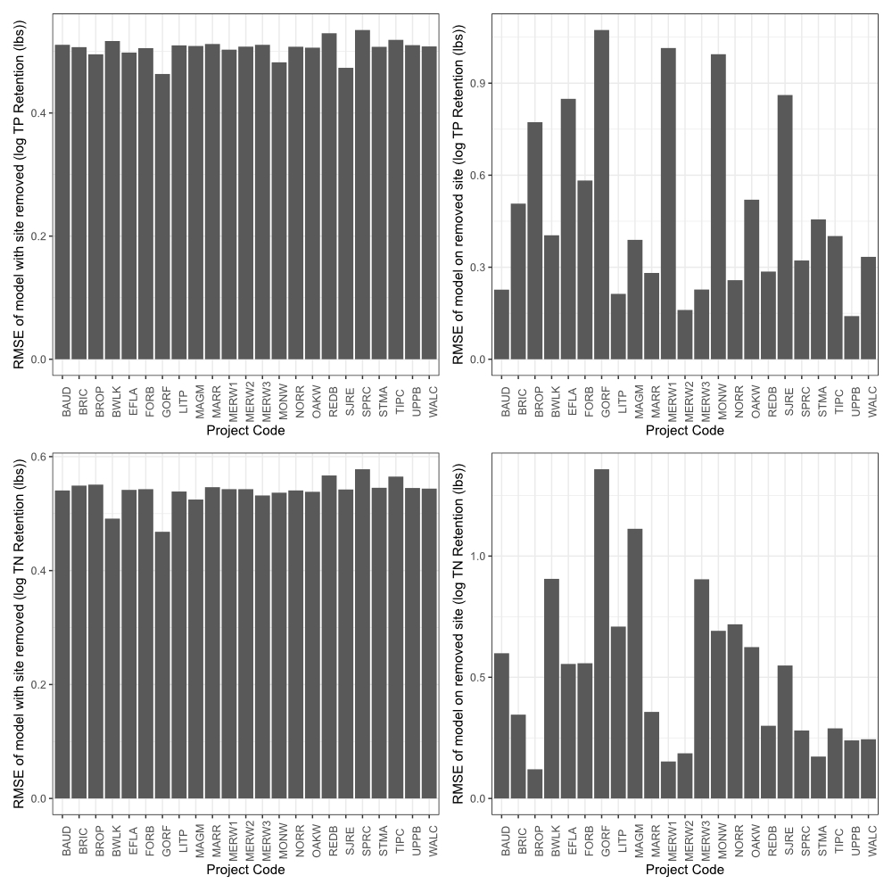
Figure S1. Root mean square error (RMSE) of linear models of monthly TP retention ~ inflow volume. Each bar represents the RMSE for a) the model with the listed wetland removed or b) the performance of the model predicting TP retention of the removed wetland.

Table S1. Nutrient filtration across all monitoring years for H2Ohio wetlands. Filtration was calculated by measuring inflowing and outflowing nutrients to 24 different wetlands for between one and four years. Nutrient budgets were calculated for total phosphorus (TP), total nitrogen (TN), dissolved reactive phosphorus (DRP), nitrite+nitrate (NO_{x}), and total ammonium nitrogen (NH₄).
 |  |  |  | Retention (lbs. of Phosphorus or Nitrogen)
Wetland | Restored Wetland (acres) | Water Year | Inflow volume (m³) | Total P | Total N |  | DRP | NO_{x} | NH₄
BAUD | 12 | 2025 | 301,375 | 50 |  | 864 | 54 | 716 | 9
BRIC | 11 | 2025 | 77,712 | 9 |  | 234 | 1 | 162 | 1
BROP | 5 | 2023 | 1,185,291 | 24 |  | 3,294 | 21 | 2,838 | 65
 |  | 2024 | 1,214,616 | 59 |  | 4,266 | 22 | 3,781 | 94
BWLK | 27 | 2023 | 195,394 | 41 |  | 7,345 | 25 | 6,831 | 203
 |  | 2024 | 438,735 | 238 |  | 5,513 | 120 | 4,976 | 0
 |  | 2025 | 177,637 | 86 |  | 5,627 | 57 | 4,803 | -5
EFLA | 3.5 | 2024 | 867,904 | 1,733 |  | 3,388 | 122 | 647 | 127
 |  | 2025 | 1,434,010 | 611 |  | 1,378 | 61 | 198 | -75
FORB | 5 | 2023 | 15,657 | 12 |  | 29 | 0 | 3 | 0
 |  | 2024 | 10,866 | 9 |  | 21 | 0 | 2 | 0
 |  | 2025 | 20,858 | 15 |  | 36 | 0 | 2 | 0
GORF | 1 | 2024 | 115 | 0 |  | 0 | 0 | 0 | 0
 |  | 2025 | 613 | 0 |  | 0 | 0 | 0 | 0
LITP | 95 | 2025 | 149,847 | 38 |  | 1,177 | 16 | 1,221 | 134
MAGM | 173 | 2024 | 149,224 | 16 |  | 290 | 2 | 8 | 11
 |  | 2025 | 623,492 | 219 |  | 729 | 119 | 227 | 362
MARR | 16 | 2025 | 8,073 | 3 |  | 13 | 3 | 16 | 0
MERW1 | 15 | 2025 | 57,229 | -11 |  | -55 | 9 | 1 | -14
MERW2 | 30 | 2025 | 54,504 | 13 |  | 219 | 7 | 1 | -2
MERW3 | 4.5 | 2025 | 263,764 | 115 |  | 2,528 | 22 | 1,810 | 61
MONW | 10 | 2024 | 11,476 | 9 |  | -33 | -10 | -2 | NA
 |  | 2025 | 18,838 | 29 |  | 184 | 15 | 85 | NA
NORR | 23 | 2025 | 151,978 | 13 |  | 648 | 3 | 532 | 43
OAKW | 20 | 2024 | 7,621 | 4 |  | 106 | 1 | 88 | 0
 |  | 2025 | 52,884 | 28 |  | 694 | 8 | 576 | -2
REDB | 25 | 2022 | 108,974 | 27 |  | 396 | 7 | 260 | 2
 |  | 2023 | 109,881 | 20 |  | 178 | 4 | 126 | 4
 |  | 2024 | 80,006 | 7 |  | 212 | 1 | 167 | 2
 |  | 2025 | 75,195 | 19 |  | 302 | 0 | 279 | 0
SJRE | 33 | 2024 | 66,141 | 1 |  | 1,075 | 14 | 750 | 28
 |  | 2025 | 134,681 | 4 |  | 1,968 | 28 | 1,701 | 89
SPRC | 25 | 2022 | 401,810 | 153 |  | 2,435 | 76 | 1,890 | 37
 |  | 2023 | 278,428 | 103 |  | 1,952 | 57 | 1,684 | 31
 |  | 2024 | 194,282 | 68 |  | 1,394 | 33 | 1,130 | 20
 |  | 2025 | 334,554 | 110 |  | 2,864 | 48 | 2,049 | 53
STMA | 31 | 2025 | 370,350 | 252 |  | 2,385 | 95 | 3 | 421
TIPC | 10 | 2023 | 256,538 | 112 |  | 1,569 | 64 | 1,745 | 25
 |  | 2024 | 269,018 | 6 |  | 1,032 | 13 | 987 | 63
 |  | 2025 | 323,796 | 73 |  | 1,791 | 43 | 1,828 | 35
TRUC | 30 | 2025 | 0 | -3 |  | -56 | -1 | -1 | -9
UPPB | 30 | 2025 | 55,267 | 2 |  | 115 | -1 | 59 | 3
WALC | 17.4 | 2023 | 770,819 | 166 |  | -549 | 117 | 380 | -24
 |  | 2024 | 1,687,419 | 497 |  | 4,789 | 295 | 6,904 | -20

Table S2. H2Ohio wetlands monitored.
Wetland Code | Short Name | Long Name | County | Wetland Type
BAUD | Baughman Ditch | Baughman H2Ohio Wetland Restoration Project | Allen
BRIC | Bright Wetland | Bright Conservation Area Wetland Restoration Initiative | Hancock | Flow-through, depressional
BROP | Brooks Park | Brooks Park Wetland Creation & Water Quality Initiative | Fairfield | Depressional
BWLK | Burntwood-Langenkamp | Burntwood-Langenkamp Wetland Conservation Area | Mercer | Isolated
EFLA | Williamsburg Wetland | East Fork Riparian Reserve Wetland Treatment System | Clermont | Floodplain
FORB | Forder Bridge | Forder Bridge Floodplain Reconnection | Paulding | Flow-through
GORF | Gorman Farms | Gorman Heritage Farm Treatment Wetland System | Hamilton | Floodplain
LITP | Little Portage | Little Portage Nutrient Reduction & Coastal Wetland Restoration | Ottawa | Flow-through
MAGM | Magee Marsh | Magee Marsh Turtle Creek Bay Wetland Reconnection | Ottawa | Depressional
MARR | Martin's Run | Martin's Run Wetland and Stream Restoration Project | Lorain | Flow-through
MERW | Mercer Wetland | Mercer Wetland Complex Restoration | Mercer | Depressional
MONW | Montpelier Wetland | OSU Montpelier Wetland Restoration | Williams | Depressional
NORR | North Ridge | North Ridge Hunt Club Wetland Restoration | Ottawa | Floodplain
OAKW | Oakwoods West | Oakwoods Nature Preserve Wetland Restoration Project, West | Hancock | Flow-through
REDB | Redhorse Bend | Redhorse Bend Preserve Wetland Restoration | Williams | Flow-through, depressional
SJRE | St. Joe's Restoration | St. Joseph's River Restoration Project | Williams | Depressional
SPRC | Springcreek Confluence | Springcreek Confluence Off-Channel Wetlands | Miami | Depressional, flow-through
STMA | St. Mary's | City of St Marys Treatment Train | Auglaize | Coastal
TIPC | Tipp City | Tipp City Off-Channel Wetland | Miami | Floodplain
TRUC | Trumbull Creek | Trumbull Creek H2Ohio | Ashtabula | Floodplain
UPPB | Upper Blanchard | Upper Blanchard River Watershed Project | Wyandot | Floodplain
WALC | Walnut Creek | Walnut Creek Treatment Wetland Restoration | Franklin | Depressional
 |  |  |  | Depressional

Conflict of Interest Statement:

Acknowledgements:
ADD IN STATEMENT ABOUT H2OHIO FUNDING
This material is in part based upon work supported by the Great Lakes Restoration Initiative (GLRI) and funded under grant EPA-R5-GL00E03253.
ADD IN STATEMENT ABOUT H2OHIO ADVISORY GROUP
The authors thank the H₂Ohio GLRI Sensor Network Advisory Group for advice and feedback during the development of this manuscript: Nandita Basu, Whitney Beck, Jacob Berkowitz, Paul Gledhill, Heather Golden, Matt Pawlowski, Katie Quesnell, Craig Stow, Santina Wortman. The authors thank Robin Miller for editing, advice, and comments during the writing of this manuscript.

References:
Aldous, A., P. McCormick, C. Ferguson, S. Graham, and C. Craft. 2005. Hydrologic Regime Controls Soil Phosphorus Fluxes in Restoration and Undisturbed Wetlands. Restoration Ecology 13:341–347.
Allen, R. G., L. S. Pereira, D. Raes, and M. Smith. 1998. Crop evapotranspiration-Guidelines for computing crop water requirements-FAO Irrigation and drainage paper 56. Fao, rome 300:D05109.
Anderson, D. M., P. M. Glibert, and J. M. Burkholder. 2002. Harmful algal blooms and eutrophication: Nutrient sources, composition, and consequences. Estuaries 25:704–726.
Anderson, K. J., B. Adhikari, O. F. Schloegel, R. Marques Mendonca, M. P. Back, N. Brocato, J. A. Cianci-Gaskill, S. E. McMurray, C. Bahlai, D. M. Costello, and L. Kinsman-Costello. 2024. We know less about phosphorus retention in constructed wetlands than we think we do: A quantitative literature synthesis. Ecological Indicators 169:112969.
Ardón, M., S. Montanari, J. L. Morse, M. W. Doyle, and E. S. Bernhardt. 2010. Phosphorus export from a restored wetland ecosystem in response to natural and experimental hydrologic fluctuations. Journal of Geophysical Research: Biogeosciences 115.
Atkinson, C. L., and C. C. Vaughn. 2015. Biogeochemical hotspots: temporal and spatial scaling of the impact of freshwater mussels on ecosystem function. Freshwater Biology 60:563–574.
Aziz, T., and P. Van Cappellen. 2021. Economic valuation of suspended sediment and phosphorus filtration services by four different wetland types: A preliminary assessment for southern Ontario, Canada. Hydrological Processes 35:e14442.
Back, M. P., G. A. Watson, E. B. Campbell, H. C. Esber, J. Myers, C. Kohart, W. R. Midden, S. E. Newell, and L. E. Kinsman-Costello. 2025. Sediment-water nutrient exchange across a diked Lake Erie coastal wetland, Ohio, USA. Journal of Great Lakes Research 51:102658.
Bingham, M., S. K. Sinha, and F. Lupi. 2015. Economic benefits of reducing harmful algal blooms in Lake Erie. Environmental Consulting & Technology, Inc., Report 66.
Carpenter, S. R., N. F. Caraco, D. L. Correll, R. W. Howarth, A. N. Sharpley, and V. H. Smith. 1998. Nonpoint Pollution of Surface Waters with Phosphorus and Nitrogen. Ecological Applications 8:559–568.
Cheng, F. Y., and N. B. Basu. 2017. Biogeochemical hotspots: Role of small water bodies in landscape nutrient processing. Water Resources Research 53:5038–5056.
Cheng, F. Y., J. Park, M. Kumar, and N. B. Basu. 2023. Disconnectivity matters: the outsized role of small ephemeral wetlands in landscape-scale nutrient retention. Environmental Research Letters 18:024018.
Collins, S. D., S. Shukla, and N. K. Shrestha. 2016. Drainage ditches have sufficient adsorption capacity but inadequate residence time for phosphorus retention in the Everglades. Ecological Engineering 92:218–228.
Craft, C. B. 1996. Dynamics of nitrogen and phosphorus retention during wetland ecosystem succession. Wetlands Ecology and Management 4:177–187.
D’Amario, S. C., H. F. Wilson, and M. A. Xenopoulos. 2021. Concentration‐discharge relationships derived from a larger regional dataset as a tool for watershed management. Ecological Applications 31:e02447.
Díaz, F. J., A. T. O′Geen, and R. A. Dahlgren. 2012. Agricultural pollutant removal by constructed wetlands: Implications for water management and design. Agricultural Water Management 104:171–183.
Dunne, E. J., M. F. Coveney, V. R. Hoge, R. Conrow, R. Naleway, E. F. Lowe, L. E. Battoe, and Y. Wang. 2015. Phosphorus removal performance of a large-scale constructed treatment wetland receiving eutrophic lake water. Ecological Engineering 79:132–142.
Fennessy, M. S., A. D. Jacobs, and M. E. Kentula. 2007. An evaluation of rapid methods for assessing the ecological condition of wetlands. Wetlands 27:543–560.
Hambäck, P. A., L. Dawson, P. Geranmayeh, J. Jarsjö, I. Kačergytė, M. Peacock, D. Collentine, G. Destouni, M. Futter, G. Hugelius, S. Hedman, S. Jonsson, B. K. Klatt, A. Lindström, J. E. Nilsson, T. Pärt, L. D. Schneider, J. A. Strand, P. Urrutia-Cordero, D. Åhlén, I. Åhlén, and M. Blicharska. 2023. Tradeoffs and synergies in wetland multifunctionality: A scaling issue. Science of The Total Environment 862:160746.
Hamner, B., M. Frasco, and E. LeDell. 2018. Package ‘metrics.’ R Foundation for Statistical Computing.
Hanrahan, B. R., K. W. King, M. R. Williams, E. W. Duncan, L. A. Pease, and G. A. LaBarge. 2019. Nutrient balances influence hydrologic losses of nitrogen and phosphorus across agricultural fields in northwestern Ohio. Nutrient Cycling in Agroecosystems 113:231–245.
Heisler, J., P. M. Glibert, J. M. Burkholder, D. M. Anderson, W. Cochlan, W. C. Dennison, Q. Dortch, C. J. Gobler, C. A. Heil, E. Humphries, A. Lewitus, R. Magnien, H. G. Marshall, K. Sellner, D. A. Stockwell, D. K. Stoecker, and M. Suddleson. 2008. Eutrophication and harmful algal blooms: A scientific consensus. Harmful Algae 8:3–13.
International Joint Commission. 2014. A Balanced Diet for Lake Erie. International Joint Commission.
Jacquemin, S. J., M. C. Grunden, and T. A. Dirksen. 2025. Wetland Conservation in the Grand Lake St. Marys Watershed: Long Term Monitoring Data from Coldwater Creek Restored Wetland. Wetlands 45:37.
Jacquemin, S. J., L. T. Johnson, T. A. Dirksen, and G. McGlinch. 2018. Changes in Water Quality of Grand Lake St. Marys Watershed Following Implementation of a Distressed Watershed Rules Package. Journal of Environmental Quality 47:113–120.
Jiang, B., and W. J. Mitsch. 2020. Influence of hydrologic conditions on nutrient retention, and soil and plant development in a former central Ohio swamp: A wetlaculture mesocosm experiment. Ecological Engineering 157:105969.
Johnson, L. T., N. Manning, J. Dezse, J. Boehler, E. Clark, T. Fulton, N. Miller, and A. Roerdink. 2024. Drivers of annual suspended sediment and nutrient yields in tributaries to Lake Erie. Aquatic Ecosystem Health & Management 26:5–19.
Jordan, T. E., D. F. Whigham, K. H. Hofmockel, and M. A. Pittek. 2003. Nutrient and Sediment Removal by a Restored Wetland Receiving Agricultural Runoff. Journal of Environmental Quality 32:1534–1547.
Kadlec, R. H. 2016. Large Constructed Wetlands for Phosphorus Control: A Review. Water 8:243.
Kinsman-Costello, L. E., K. Fussel, C. Winslow, J. Kerns, O. Schloegel, R. Mendonça, R. Becker, T. B. Bridgeman, K. Doro, S. J. Jacquemin, L. Johnson, G. Liu, K. McCluney, H. Michaels, W. R. Midden, S. E. Newell, M. Back, L. Brown, I. Rahman, and Z. Swan. 2024. H2Ohio Wetland Monitoring Program:Monitoring Framework. Columbus, OH, USA.
Kinsman-Costello, L. E., J. O’Brien, and S. K. Hamilton. 2014. Re-flooding a Historically Drained Wetland Leads to Rapid Sediment Phosphorus Release. Ecosystems 17:641–656.
Lake Erie and Aquatic Research Network (LEARN): Wetlands and Water Quality Group (H2Ohio Wetland Monitoring Program). 2026. H2Ohio Wetland Monitoring Program 2025 Annual Report.
Land, M., W. Granéli, A. Grimvall, C. C. Hoffmann, W. J. Mitsch, K. S. Tonderski, and J. T. A. Verhoeven. 2016. How effective are created or restored freshwater wetlands for nitrogen and phosphorus removal? A systematic review. Environmental Evidence 5:9.
Marton, J. M., I. F. Creed, D. B. Lewis, C. R. Lane, N. B. Basu, M. J. Cohen, and C. B. Craft. 2015. Geographically isolated wetlands are important biogeochemical reactors on the landscape. Bioscience 65:408–418.
Matisoff, G., E. M. Kaltenberg, R. L. Steely, S. K. Hummel, J. Seo, K. J. Gibbons, T. B. Bridgeman, Y. Seo, M. Behbahani, W. F. James, L. T. Johnson, P. Doan, M. Dittrich, M. A. Evans, and J. D. Chaffin. 2016. Internal loading of phosphorus in western Lake Erie. Journal of Great Lakes Research 42:775–788.
McLatchey, G. P., and K. R. Reddy. 1998. Regulation of Organic Matter Decomposition and Nutrient Release in a Wetland Soil. Journal of Environmental Quality 27:1268–1274.
Michalak, A. M., E. J. Anderson, D. Beletsky, S. Boland, N. S. Bosch, T. B. Bridgeman, J. D. Chaffin, K. Cho, R. Confesor, I. Daloğlu, J. V. DePinto, M. A. Evans, G. L. Fahnenstiel, L. He, J. C. Ho, L. Jenkins, T. H. Johengen, K. C. Kuo, E. LaPorte, X. Liu, M. R. McWilliams, M. R. Moore, D. J. Posselt, R. P. Richards, D. Scavia, A. L. Steiner, E. Verhamme, D. M. Wright, and M. A. Zagorski. 2013. Record-setting algal bloom in Lake Erie caused by agricultural and meteorological trends consistent with expected future conditions. Proceedings of the National Academy of Sciences 110:6448–6452.
Mitsch, W. J. 2017. Solving Lake Erie’s harmful algal blooms by restoring the Great Black Swamp in Ohio. Ecological Engineering 108:406–413.
Mitsch, W. J., S. M. Nedrich, S. K. Harter, C. Anderson, A. M. Nahlik, and B. Bernal. 2014. Sedimentation in created freshwater riverine wetlands: 15 years of succession and contrast of methods. Ecological Engineering 72:25–34.
Ohio Department of Natural Resources. 2026. H2Ohio. https://ohiodnr.gov/discover-and-learn/safety-conservation/about-ODNR/water-resources/h2ohio.
Ohio Environmental Protection Agency (EPA). 2023. Maumee Watershed Nutrient Total Maximum Daily Load. Division of Surface Water, Assessment and Modeling Section, Columbus, OH, USA.
Paerl, H. W., J. D. Chaffin, J. H. Cheshire, H. E. Plaas, M. A. Barnard, L. B. Goerlitz, J. S. Braddy, A. Sabo, L. M. Nelson, and L. Yue. 2024. Dual phosphorus and nitrogen nutrient reduction will be more effective than a phosphorus-only reduction in mitigating diatom and cyanobacterial blooms in Lake Erie, USA–Canada. Limnology and Oceanography 69:2913–2928.
Prein, A. F., and L. O. Mearns. 2021. U.S. Extreme Precipitation Weather Types Increased in Frequency During the 20th Century. Journal of Geophysical Research: Atmospheres 126:e2020JD034287.
R Core Team. 2024. R: A language and environment for statistical computing. R Foundation for Statistical Computing, Vienna Austria.
Sharpley, A., H. P. Jarvie, A. Buda, L. May, B. Spears, and P. Kleinman. 2013. Phosphorus Legacy: Overcoming the Effects of Past Management Practices to Mitigate Future Water Quality Impairment. Journal of Environmental Quality 42:1308–1326.
Smith, V. H., and D. W. Schindler. 2009. Eutrophication science: where do we go from here? Trends in ecology & evolution 24:201–207.
Sparks, A. 2018. nasapower: A NASA POWER Global Meteorology, Surface Solar Energy and Climatology Data Client for R. Journal of Open Source Software 3:1035.
Steinman, A. D., and M. E. Ogdahl. 2011. Does converting agricultural fields to wetlands retain or release P? Journal of the North American Benthological Society 30:820–830.
Steinman, A. D., M. E. Ogdahl, M. Weinert, K. Thompson, M. J. Cooper, and D. G. Uzarski. 2012. Water level fluctuation and sediment–water nutrient exchange in Great Lakes coastal wetlands. Journal of Great Lakes Research 38:766–775.
Tanner, C. C., and J. P. S. Sukias. 2011. Multiyear Nutrient Removal Performance of Three Constructed Wetlands Intercepting Tile Drain Flows from Grazed Pastures. Journal of Environmental Quality 40:620–633.
Ury, E. A., P. Arrumugam, E. R. Herbert, P. Badiou, B. Page, and N. B. Basu. 2023. Source or sink? Meta-analysis reveals diverging controls of phosphorus retention and release in restored and constructed wetlands. Environmental Research Letters 18:083002.
USDA-NRCS. 2004. Estimation of Direct Runoff from Storm Rainfall. Page National Engineering Handbook, Title 210 Engineering. United States Department of Agriculture Natural Resources Conservation Service.
Vymazal, J. 2007. Removal of nutrients in various types of constructed wetlands. Science of The Total Environment 380:48–65.
Weisner, S. E. B., K. Johannesson, G. Thiere, H. Svengren, P. M. Ehde, and K. S. Tonderski. 2016a. National Large-Scale Wetland Creation in Agricultural Areas—Potential versus Realized Effects on Nutrient Transports. Water 8:544.
Weisner, S. E. B., K. Johannesson, G. Thiere, H. Svengren, P. M. Ehde, and K. S. Tonderski. 2016b. National Large-Scale Wetland Creation in Agricultural Areas—Potential versus Realized Effects on Nutrient Transports. Water 8:544.
Wurtsbaugh, W. A., H. W. Paerl, and W. K. Dodds. 2019. Nutrients, eutrophication and harmful algal blooms along the freshwater to marine continuum. WIREs Water 6:e1373.

